**12. Design DFA using simulator to accept the input string “a” ,”ac”,and ”bac”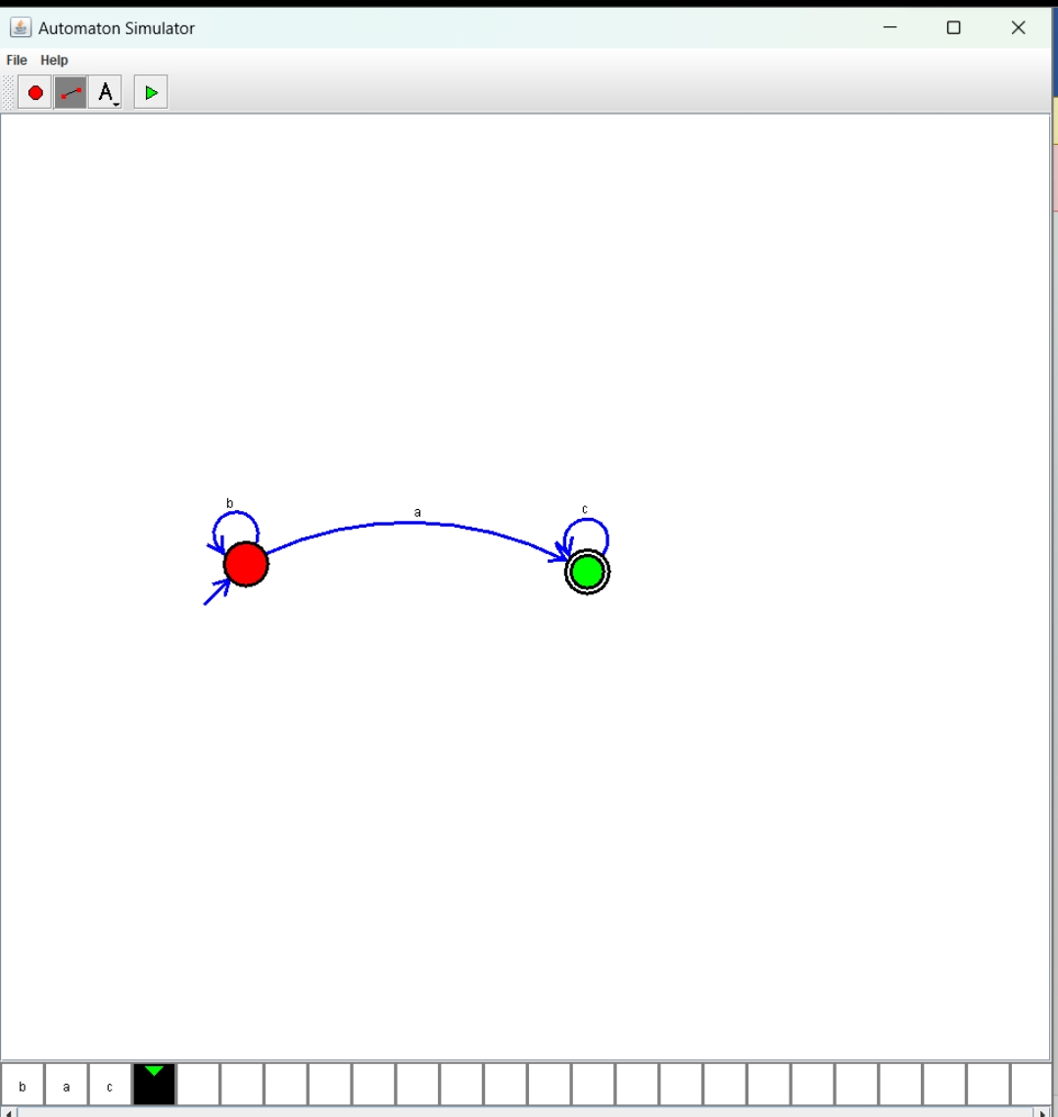Result: Hence, we Design DFA using simulator to accept the input string “a” ,”ac” and ”bac”.**